Earthworks - ITP

**Hayden Brett**

Created Tue, 16 Jan 2024, 3:46 PM (UTC+11)

**Subcontractor (if applicable)**

**ITP Details:**

|  |  |  |  |  |  |  |
| --- | --- | --- | --- | --- | --- | --- |
| **Client** | **Construction Process** | **Contract Number:** | **Speciﬁcations** | **Structure / Component** | **Prepared By** | **Approved By** |
| *Regional Roads Victoria* | Earthworks |  | *Vicroads Speciﬁcation Section 173, 175, 204,*  *205, 210, 290, 304, 702*  *and 720, VR Code of Practice 500.2* | *Pavements* |  |  |

**Project Location Lot Number**

**Lot Details**

**Lot size/Qty**

**Date** Start: - End: -

**Legend:**





1. **Preliminary Works**

|  |  |  |  |  |  |  |  |  |
| --- | --- | --- | --- | --- | --- | --- | --- | --- |
| **Task/Activity Description** | **Acceptance Criteria** | **Reference Document s** | **Method & Record of conformity** | **Responsib ility** | **Signature 1** | **Reports** | **Pictures** | **Comments** |
| **1.1** Check for correct documentation  **Frequency**  Prior to commencing any activity | Ensure that all employees and subcontractors are:  -using the correct and complete set of drawings  -all drawings are the latest revision | IFC  Drawings | **Method**: Visual Inspection  **Record**: Signed ITP | IHP  SWA  Project Manager |  |  |  |  |

|  |  |  |  |  |  |  |  |  |
| --- | --- | --- | --- | --- | --- | --- | --- | --- |
| **Task/Activity Description** | **Acceptance Criteria** | **Reference Document s** | **Method & Record of conformity** | **Responsib ility** | **Signature 1** | **Reports** | **Pictures** | **Comments** |
| **1.2** Implementation of all measures and controls  **Frequency**  Prior to commencing any activity | All necessary measures and controls are being implemented, that is: EMP, TMP & SWMS. | EMP, TMP & SWMS | **Method**: Visual Inspection  **Record**: Signed ITP | IHP  SWA  Project Manager |  |  |  |  |

1. **Construction works**

|  |  |  |  |  |  |  |  |  |
| --- | --- | --- | --- | --- | --- | --- | --- | --- |
| **Task/Activity Description** | **Acceptance Criteria** | **Reference Document s** | **Inspection method & Record of conformity** | **Responsib ility** | **Signature 1** | **Reports** | **Photos** | **Comments** |
| **2.1** Survey Set-Out  **Frequency**:Prior to commencement of excavation. | Area has been set out in accordance with the drawings | Work Procedure | **Method**: Verify  **Record**: Signed ITP | IP  SWA  Project Manager |  |  |  |  |

|  |  |  |  |  |  |  |  |  |
| --- | --- | --- | --- | --- | --- | --- | --- | --- |
| **Task/Activity Description** | **Acceptance Criteria** | **Reference Document s** | **Inspection method & Record of conformity** | **Responsib ility** | **Signature 1** | **Reports** | **Photos** | **Comments** |
| **2.2** Excavation Permit  **Frequency**:Each Lot | An excavation permit or DBYD must be issued prior to any excavation commencing. Plant and equipment shall be appropriate for the task. Excavation operations shall not disturb areas outside the limit of excavation | Excavation Permit | **Method**: Verify  **Record**: Signed ITP | IHP  SWA  Project Manager  IP  SWA SEQ  Adviser |  |  |  |  |
| **2.3** Sub grade Material Properties  **Frequency**:Each Lot | In situ material within 400mm of cut ﬂoor level to be consistent with Type B. i.e.  CBR>assigned value (must be greater than 2), Swell < 2.5%.  If parameter met, rip and re compact 150mm. If parameters not met remove 400mm of material and replace with conforming type B. | VcRoads Std Specs  204.06 (e) | **Method**: Site Inspection/Test Report  **Record**: Signed ITP & Test Report | **TP**  SWA  Project Manager  External testing Company representat ive  **AP**  RRV  Superinten dent |  |  |  |  |

|  |  |  |  |  |  |  |  |  |
| --- | --- | --- | --- | --- | --- | --- | --- | --- |
| **Task/Activity Description** | **Acceptance Criteria** | **Reference Document s** | **Inspection method & Record of conformity** | **Responsib ility** | **Signature 1** | **Reports** | **Photos** | **Comments** |
| **2.4** Inspection of Subgrade Material  **Frequency**:Each Lot | Prior to commencing excavation in any area and during excavation work, the Superintendent and the Contractor shall inspect each type of material encountered and subject to veriﬁcation by appropriate laboratory testing, agree on the category of the material in accordance with Clause 204.04 | VcRoads Std Specs  204.06 (e) | **Method**: Visual Inspection  **Record**: Signed ITP | IHP  SWA  Project Manager  **AP**  RRV  Superinten dent |  |  |  |  |
| **2.5** Material Classiﬁed as Silt  **Frequency**:Prior to commencing | Material classiﬁed as silt, either before or after compaction, is not acceptable as Type A material without stabilisation to the satisfaction of the Superintendent. | VcRoads Std Specs  204.04 (e) | **Method**: Visual Inspection  **Record**: Signed ITP | IHP  SWA  Project Manager  **AP**  RRV  Superinten dent |  |  |  |  |

|  |  |  |  |  |  |  |  |  |
| --- | --- | --- | --- | --- | --- | --- | --- | --- |
| **Task/Activity Description** | **Acceptance Criteria** | **Reference Document s** | **Inspection method & Record of conformity** | **Responsib ility** | **Signature 1** | **Reports** | **Photos** | **Comments** |
| **2.6** : Acceptance of Rock Subgrade (when applicable)  **Frequency :** Prior construction of the regulating layer. | Prior to construction of the regulating layer, the areas of rock subgrade shall be presented to the Superintendent for acceptance.  Any necessary amendments to the subsurface drainage design including transverse subsurface drainage at the interfaces shall be presented to Superintendent for review. | VcRoads Std Specs  204.04 (f) | **Method**: Site Inspection/ Document Review  **Record**: Signed ITP | IHP  SWA  Project Manager  **AP**  RRV  Superinten dent |  |  |  |  |
| **2.7** : Unsuitable Material  **Frequency :** Each lot as required | Where unsuitable material is encountered, proposed in-situ treatment must be submitted to the superintendent for review | VcRoads Std Specs  204.07 (d) | **Method**: Visual Inspection  **Record**: Signed ITP & Test Reports | IHP  SWA  Project Manager  **AP**  RRV  Superinten dent  **TP**  External testing Company representat ive |  |  |  |  |

|  |  |  |  |  |  |  |  |  |
| --- | --- | --- | --- | --- | --- | --- | --- | --- |
| **Task/Activity Description** | **Acceptance Criteria** | **Reference Document s** | **Inspection method & Record of conformity** | **Responsib ility** | **Signature 1** | **Reports** | **Photos** | **Comments** |
| **2.8**: Groundwater  **Frequency :** Each lot as required | Where groundwater is encountered the contractor shall notify the superintendent and submit proposed action for review. The Contractor shall submit any necessary approvals from relevant authorities for the treatment and disposal of this groundwater. | VcRoads Std Specs  204.07 (h) | **Method**: Visual Inspection  **Record**: Signed ITP & Test Reports | IHP  SWA  Project Manager  **AP**  RRV  Superinten dent |  |  |  |  |
| **2.9**: Trimming and level conformity  **Frequency :** Each lot as required | The level at any point on the subgrade shall not lie more than 20 mm below a 3 m straightedge laid in any direction, except across a crown and water shall not pond at any point.  **Level tolerances: Range** x (Mean value of all measurements) (Scale A) x = +5, -25mm (Scale B )x = +5, -15mm **Max S** (Standard deviation of all readings) (Scale A) = 12 mm (Scale B) = 15 mm  **No. measurements** (Scale A) 80 per lot (Scale B) 40 per lot | VcRoads Std 204.03  (f,g,h) Table 204.031 | **Method**: Survey  **Record**: Signed ITP & Survey Report | **SCP**  SWA  Project Manager  External Surveyor |  |  |  |  |

1. **Testing Requirements**

|  |  |  |  |  |  |  |  |  |
| --- | --- | --- | --- | --- | --- | --- | --- | --- |
| **Task/Activity Description** | **Acceptance Criteria** | **Reference Document s** | **Record of conformity** | **Responsib ility** | **Signature 1** | **Reports** | **Photos** | **Comments** |
| **3.1**: Test Rolling  **Frequency :** Each lot as required | No visible deformation or springing in presence of Superintendent's Rep. ( Cl 173) Plant to comply with requirements of Cl 173.03.  Pneumatic tyred plant nominated for test rolling procedures shall have a mass of not less than  20 tonne and shall have a ground contact pressure under either the front or rear wheels of not less than 450 kPa per tyre. | *Vicroads Speciﬁcatio n Section*173  .03  173.03 (ii) | **Method**: Visual Inspection  **Record**: Signed ITP | IHP  SWA  Project Manager  **WP**  RRV  Superinten dent |  |  |  |  |
| **3.2**: Compaction Testing  **Frequency :** Each lot as required | Ripped and re- compacted material below Cut Floor Level = minimum compaction 98%.  Type B Material placed within 400 mm of top of Type B Material = minimum compaction 98%.  Type B material 400mm below the top of Type B material and Top 150mm of where ﬁll is to be constructed = minimum compaction 95%. | *Vicroads Speciﬁcatio n* Table 204.131 | **Method**: Compaction Test  **Record**: Signed ITP & Test Reports | IHP  SWA  Project Manager  **AP**  RRV  Superinten dent  **TP**  External testing Company representat ive |  |  |  |  |

**Appendix**

Tables:

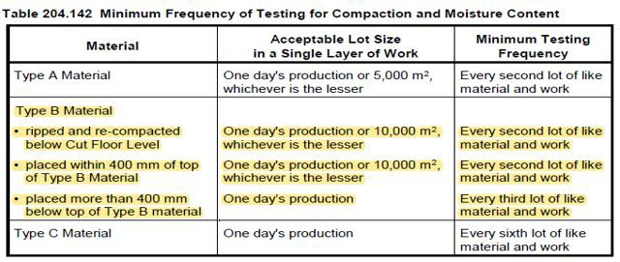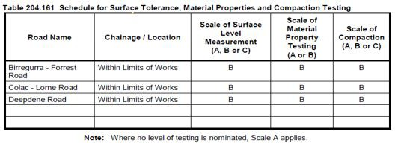

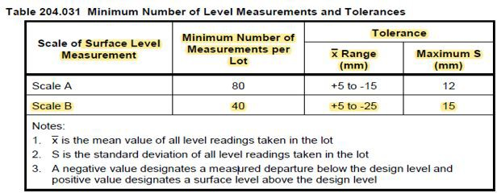

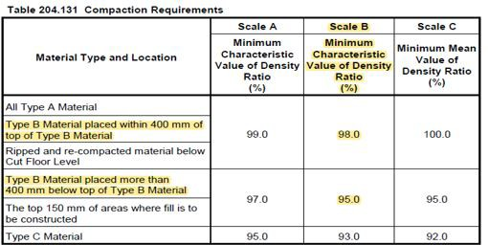

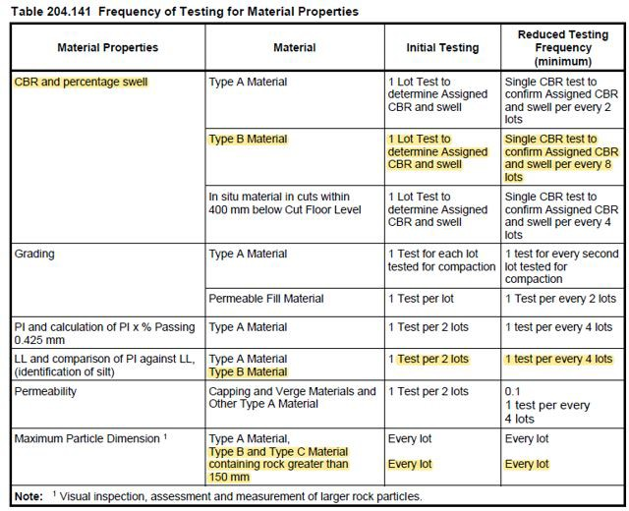

**Final Notes Photo and video**

**Final Inspection:**

The signature below veriﬁes that this ITP has been completed in accordance with the Fulton Hogan’s Quality system Procedures and veriﬁes lot compliance with speciﬁcations.

**Project Team signature** -

**Final Inspection:**

The signature below veriﬁes that this ITP has been completed in accordance with the Fulton Hogan’s Quality system Procedures and veriﬁes lot compliance with speciﬁcations.

**Client Signature** -